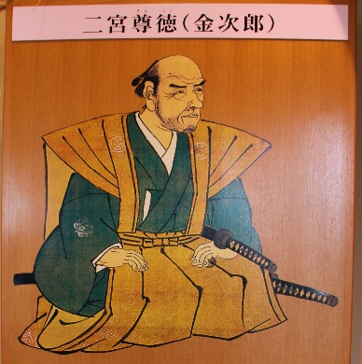
Ninomiya Sontoku (二宮 尊徳)
尊（とうとい、ソン son）：precious / reverend
徳（とく、トク toku）：dharma / good / virtue

He is a prominent 19th-century Japanese agricultural leader, philosopher, moralist and economist, former name of Ninomiya Kinjirō (二宮 金次郎).

Life
Year | Age | Notes
1787 | 0 | Born at a farmer’s house in today’s Odawara city, Kanagawa prefecture.
1800 | 14 | His father passed away. He worked to help the family.
1802 | 16 | His mother passed away. He was placed in his uncle’s household. While working in his uncle’s land, he studied on his own, mostly reading books of Confucianism which had been left by his grandfather and his father.
1803 | 17 | His uncle scolded at using oil to read book at night. It was considered unnecessary for famers to read book. So he bought rapeseeds from his friend and planted them in a small yard. He got oil from the plants.
1806 | 20 | He obtained abandoned land on his own and transformed it into agricultural land, eventually restoring his household on his own.
1818 | 32 | He started working on recovering considerable financial difficulty of house of Hattori, a minister of Odawara clan. He was rewarded for it by head of the clan.
1822-1823 | 36-37 | He was sent to Sakuramachi village (today’s Moka city in Tochigi prefecture), a very dilapidated detached estate of the Odawara clan. He has put all of his money from selling farmyards and house in Odawara for reconstruction of the village.
1824-1828 | 38-42 | The reconstruction didn’t go well for many reasons. He asked resign but was not accepted.
1829 | 43 | He stayed at Mt. Narita for some period of time to meditate while fasting. After that, the reconstruction went well.
1833 | 47 | He started constructing a weir in Aoki village. (*1)
1842 | 56 | He took a part in field survey of Tone river diversion canal.
1843 | 57 | He changed his name to Ninomiya Sontoku.
1853 | 67 | He was signed to Nikko region reconstruction project.
1856 | 70 | Died.
(*1)
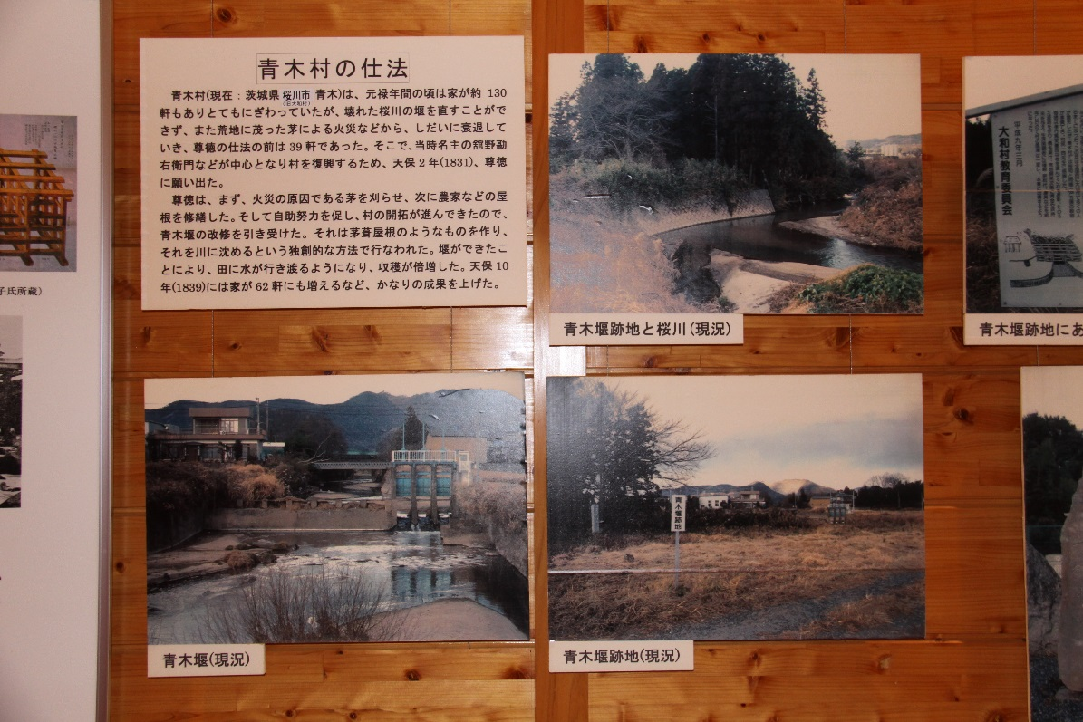

Philosophy
Ninomiya combined three strands of traditional teachings Buddhism, Shintōism and Confucianism and transformed them into practical ethical principles which matured out of his experiences. He saw agriculture as the highest form of humanity because it was the cultivation of resources given by the Kami (God).
Though he did not leave written philosophical work, his idea were later transcribed by his disciples. Here are examples.
- 報徳思想 (Houtoku Shisou)
If you contribute to the society, instead of fulfilling personal greed, the good will eventually return to you.
- 大事を成さんと欲する者は、まず小事を務むべし。
大事を成さんと欲して小事を怠り、その成り難きを憂いて、
成り易きを務めざる者は、小人の常なり。それ小を積めば大となる。
Those who wish to achieve big should take a part in small things.
The acts of wishing to achieve big but ignoring small things, worrying about how hard the ahead could be and choosing easy ways, are habits of non-achiever.
- 道徳を忘れた経済は、罪悪である。経済を忘れた道徳は、寝言である。
Economy without morality is a sin. Morality without economy is a silly talk.
- キュウリを植えればキュウリと別のものが収穫できると思うな。
人は自分の植えたものを収穫するのである。
If you plant a cucumber, don’t expect anything other than cucumber.
Humans harvest only what they plant by themselves.

Economics
Ninomiya Sontoku emphasized the importance of compound interest which was not well understood among samurai and peasants. He calculated the maturity of each interest rate for 100 years to show its significance by using the Japanese abacus (soroban). In terms of agriculture, he viewed agricultural village life as communal, where surpluses from one year were invested to develop further land or saved for worse years, and shared by members of the community. He was aware that developed land had lower tax base than established agricultural land and he was adept at financial management which he applied to his estate. He also encouraged immigrants from other estates and rewarded them if they successfully established agricultural household. He also started his own financial institutions called gojoukou, (五常講 ごじょうこう), which appear to be a forerunner of credit union. Each member of the village union could borrow fundｓ interest free for 100 days, while the entire membership shared the cost in case of default. Combination of land development, immigration and communal finance all managed under diligent utilisation of abacus was a success and became the standard methodology of economic development in feudal Japan.

Popular culture
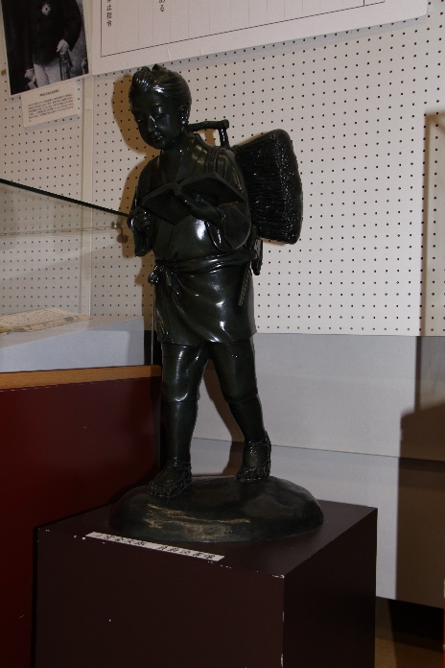
At the beginning of the Showa era, statues of him reading a book whilst carrying firewood on his back were erected in all of the elementally schools in Japan. This was because his attitude was considered good for the moral education for children. These statues are depicting popular stories that said Ninomiya was reading and studying during every moment he could.

Stone Monument
There is a stone monument, made by a mayor of Yatabe town back in 1970’s,
in Douhou park of Tsukuba city which mentions Ninomiya Sontoku’s contribution.
(Japanese only)

生回池大
仰々吾が洞峯沼は徳川時代初期天然池に人工を加へ造成せられたものと傳へられ、その後幾度かの改修を経て、吾が部落の灌漑用水の根源地となりたるものと云ふ。就中谷田部藩主細川興嗣氏時代救農治水に意を用い、相模の国より農聖二宮尊徳先生を招き、その指導により当池を利用した用水事業を起し、農業の振興を計りその跡は最近迄存置せられていたのである。然るに昭和三十七年国において研究学園都市建設の議起り谷田部町もまた将来の大発展を期し、この大業を推進し、その結果昭和四十五年当池を主体とした遊園地が計画され、その後部落においても関係者より精算人を選任し所有地全部を日本住宅公園に提供協力し、今後洞峯沼公園として生れ変ることに相成ったのである。茲に農民と共に生きた大地の精霊に感謝し、これを記念し碑を建て後昆に傅へとんとするものである。
谷田部町長 横田榮一 撰文
